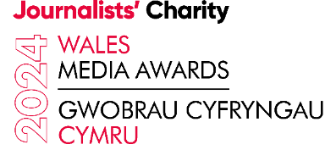

AWARDS DINNER – 15 NOVEMBER - BOOKING FORM

Name: .................................................................................................

Company Name: ………………………………………………………………………………..

Job Title: ..............................................................................................

Postal Address: ………………………………………………………………………………….

………………………………………………………………………………..

Postcode: ……………………………………….

Mobile No: ………………………………………………………………..

Email: ………………………………………………………………………………………………………

Signature: ....................................................................................

**COST OF TICKETS:**

**Individual Tickets £75.00 per person**

**Table x 10 guests £750.00 per table**

I am booking ……… Table(s) at a TOTAL cost of £…………..

I am booking ……… Individual ticket(s) at a TOTAL cost of £……………..

**If booking individual tickets please pay by bank transfer on booking as follows:**

Account Name: Journalists’ Charity

Sort Code: 40-19-22

Account No: 31376713

If booking a table(s) you will be forwarded an invoice from the Journalists’ Charity.